

ASSIGNMENT No: 30
TITLE: Write a JSP application to demonstrate CRUD operations.

Name: Avdhoot Mohite Class: CSE A2

PRN: 25070122056 Batch:25-29

Problem Statement
Write a JSP application to demonstrate CRUD operations.

Learning Objectives
To implement Create, Read, Update, and Delete operations using JSP and a database.
Theory
CRUD stands for Create, Read, Update, and Delete, which represent the four basic database operations performed in web applications. JSP works together with Servlets and JDBC to implement these operations. Users interact with HTML forms created using JSP, while JDBC executes SQL statements to manipulate database records. INSERT adds new records, SELECT retrieves information, UPDATE modifies existing data, and DELETE removes unwanted records. Proper validation, exception handling, and session management improve application reliability and security. JSP CRUD applications are widely used in employee management systems, online shopping portals, hospital management systems, banking applications, and other enterprise software.

Exercise
- Create a JSP-based application to add, update, delete, and view employee details
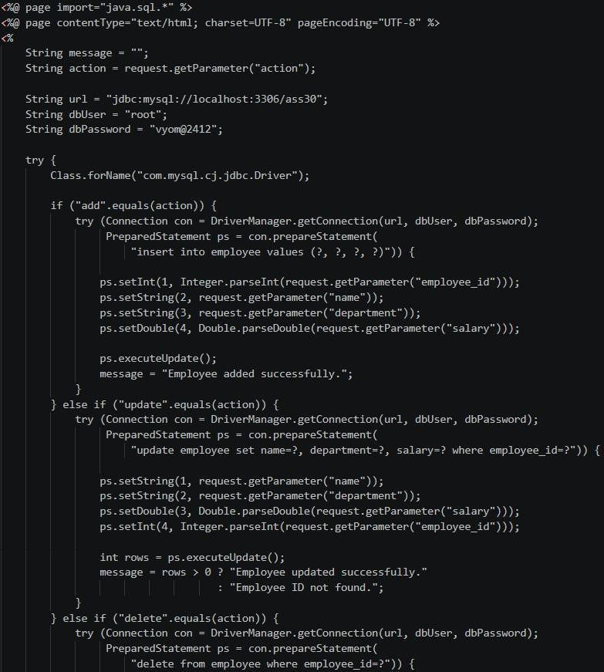

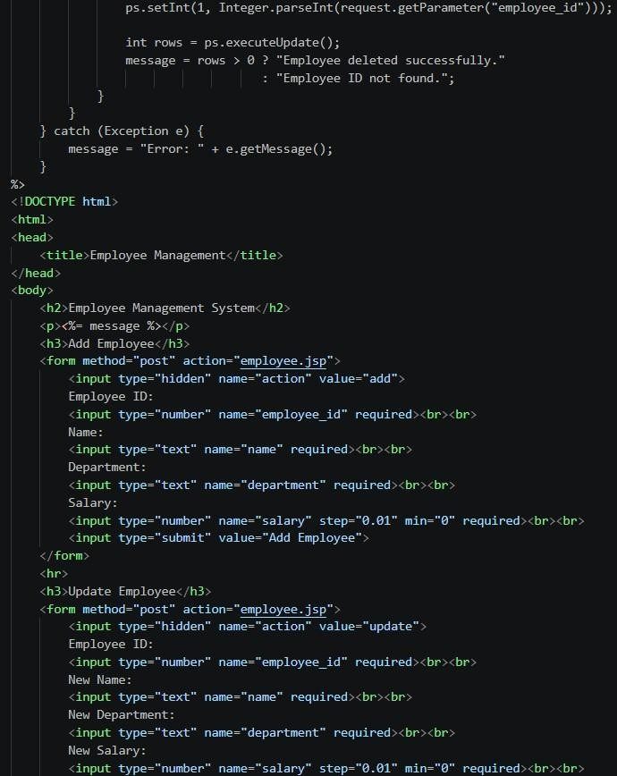

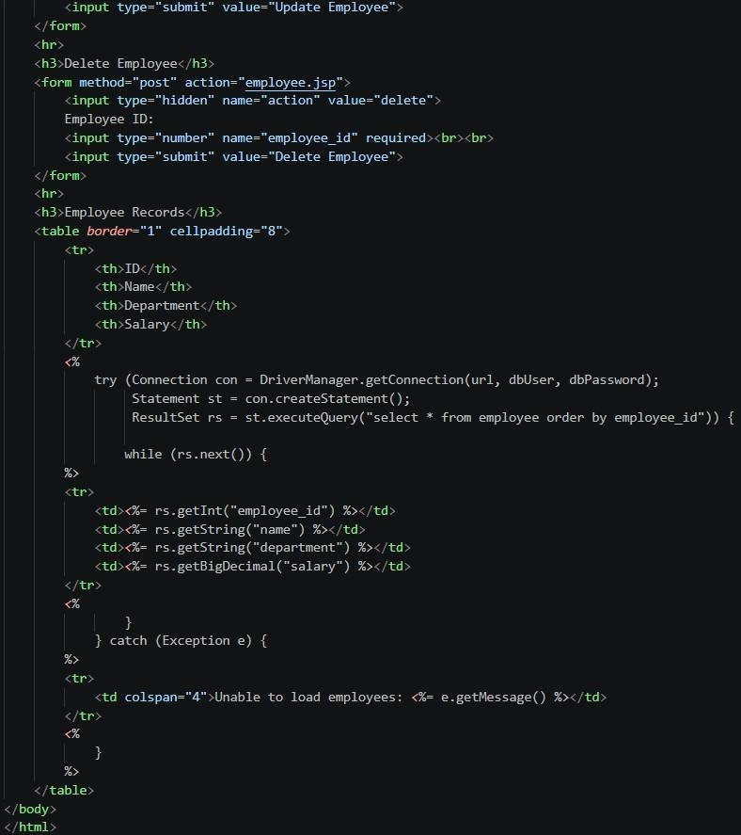

- Create a JSP-based application to manage patient records using CRUD operations. Include fields such as patient ID, name, age, disease, and treatment status.
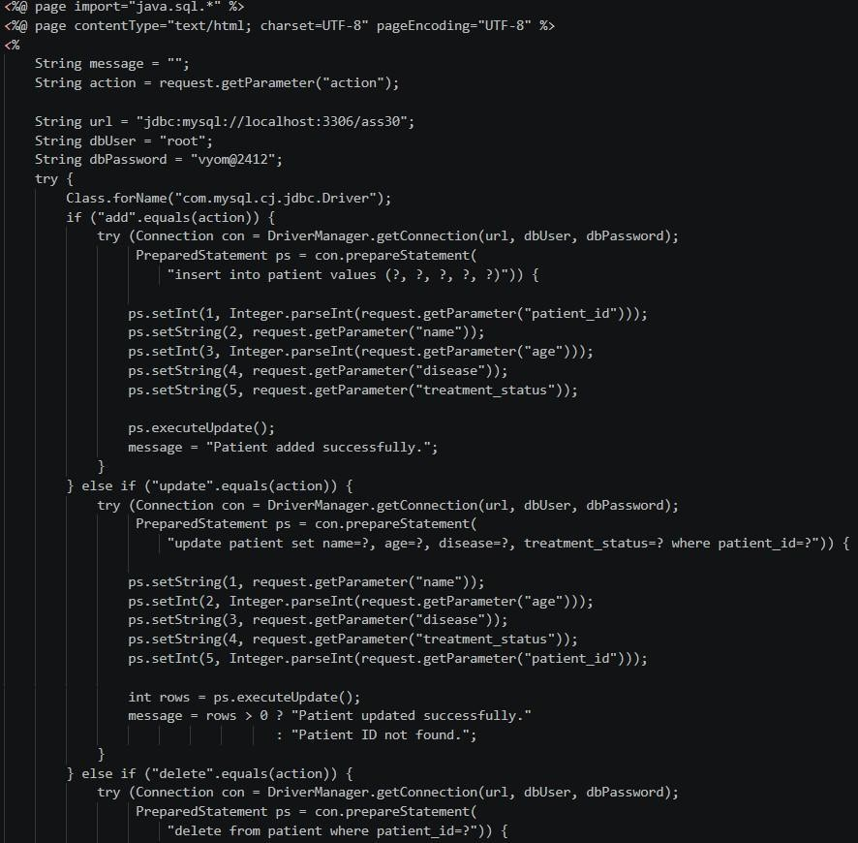

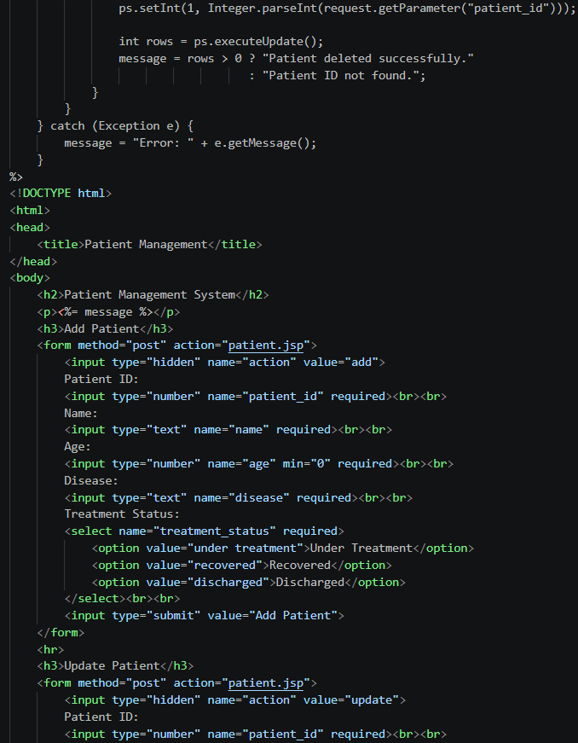

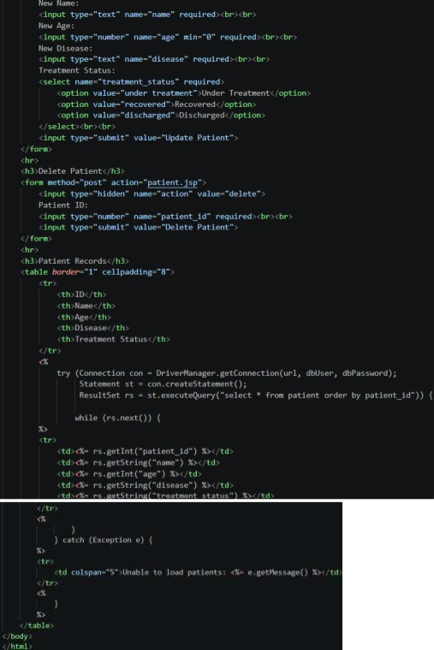

Output 1)
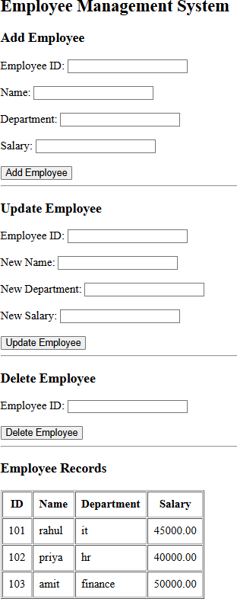

Add Employee –
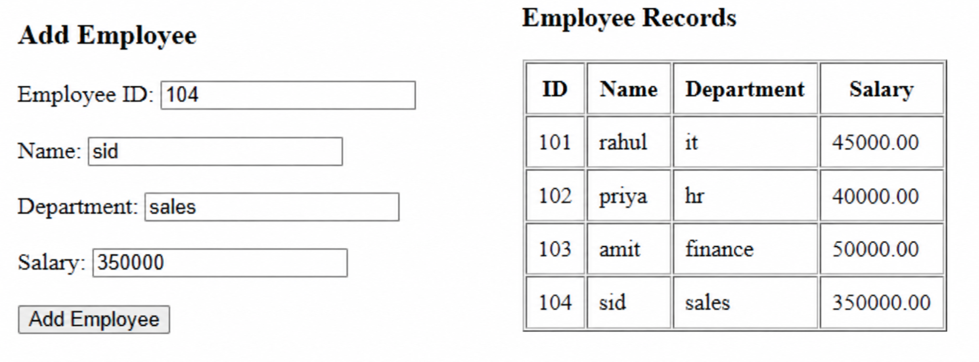

Update Employee –
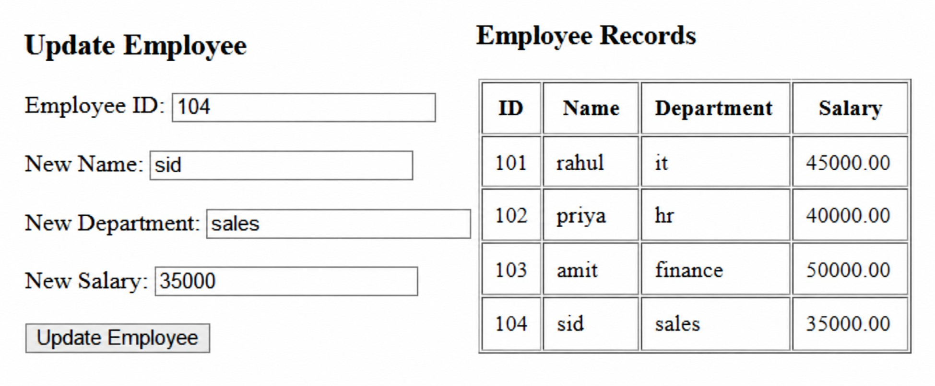

Delete Employee –

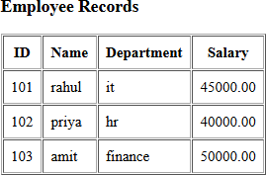

2)
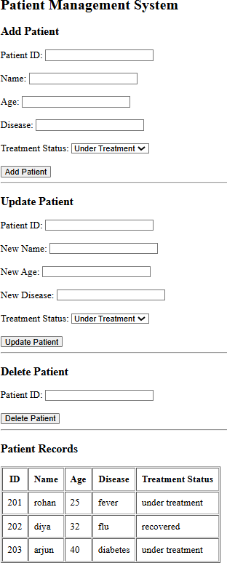

Add Patient –

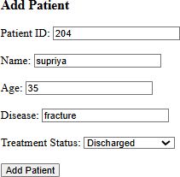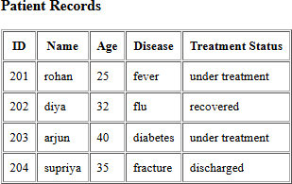

Update Patient –
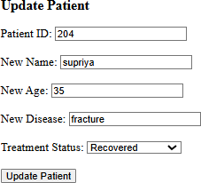
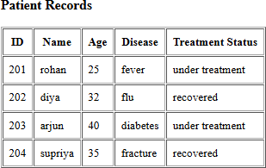

Delete Patient –

